Program No. 01. >> Simple Bar Chart Visualization
Objective: To understand basic data visualization using bar charts.
Tasks:
- Create a simple bar chart using student marks or sales data
- Explain what the bar chart represents
Outcome: Students will be able to visualize and compare categorical data using bar charts.
Tools Used: Python, NumPy, Matplotlib
Dataset: Uncleaned_Student_Dataset.csv

Script/Code:
# Objective: Learn creation and manipulation of NumPy arrays

import pandas as pd
import numpy as np
import matplotlib.pyplot as plt

# Load the dataset
df = pd.read_csv("Uncleaned_Student_Dataset.csv")

# Create 1D NumPy array from SGPA column
sgpa_array = np.array(df["sgpa"])
print("1D Array (SGPA):")
print(sgpa_array[:10])

# Create 2D NumPy array from Attendance and Internal Marks
two_d_array = np.array(df[["attendance_percentage", "internal_marks"]])
print("\n2D Array (Attendance, Internal Marks):")
print(two_d_array[:5])

# Indexing and slicing
print("\nSliced SGPA Array (Index 2 to 6):")
print(sgpa_array[2:7])

# Clean SGPA values for numerical operations
sgpa_clean = pd.to_numeric(df["sgpa"], errors="coerce").dropna()

# Element-wise operation example
print("\nElement-wise Operation (SGPA + 1):")
print((sgpa_clean.values + 1)[:10])

# Select relevant data for analysis
df_bar = df[["department", "sgpa"]].copy()
df_bar["sgpa"] = pd.to_numeric(df_bar["sgpa"], errors="coerce")
df_bar.dropna(inplace=True)

# Department-wise average SGPA
dept_avg_sgpa = df_bar.groupby("department")["sgpa"].mean()

# Bar chart visualization
plt.figure(figsize=(8, 5))
plt.bar(dept_avg_sgpa.index, dept_avg_sgpa.values)
plt.xlabel("Department")
plt.ylabel("Average SGPA")
plt.title("Department-wise Average SGPA")
plt.xticks(rotation=45)
plt.show()

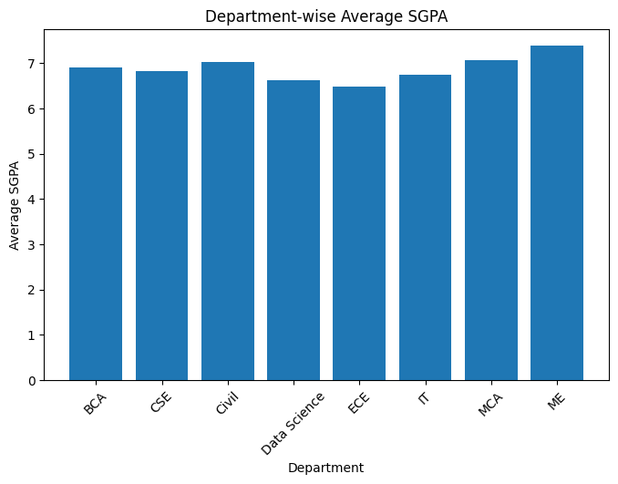
Output:

Program No. 02. >> Line Chart for Time-Based Data
Objective: To represent trends in time-based data.
Tasks:
- Draw a line chart to represent monthly attendance or sales data
- Interpret trends over time
Outcome: Students will understand trend analysis using line charts.
Tools Used: Python, Matplotlib

Script:
# Program No. 02: Line Chart for Time-Based Data
# Objective: Visualize time-based trends using a line chart

import pandas as pd
import matplotlib.pyplot as plt

# Load the dataset
df = pd.read_csv("Uncleaned_Student_Dataset.csv")

# Select required columns
df_line = df[["academic_year", "attendance_percentage"]].copy()

# Convert attendance to numeric and remove missing values
df_line["attendance_percentage"] = pd.to_numeric(
df_line["attendance_percentage"], errors="coerce"
)
df_line.dropna(inplace=True)

# Calculate year-wise average attendance
yearly_attendance = (
df_line
.groupby("academic_year")["attendance_percentage"]
.mean()
.reset_index()
.sort_values("academic_year")
)

# Create the line chart
plt.figure(figsize=(8, 5))
plt.plot(
yearly_attendance["academic_year"],
yearly_attendance["attendance_percentage"],
marker="o"
)
plt.xlabel("Academic Year")
plt.ylabel("Average Attendance (%)")
plt.title("Year-wise Average Student Attendance Trend")
plt.grid(True)
plt.show()
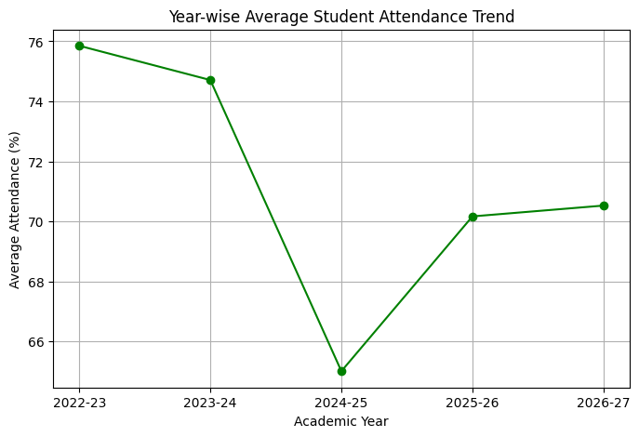
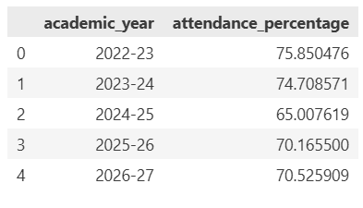
Output:

Program No. 03. >> Data Representation vs Data Presentation
Objective: To differentiate between data representation and data presentation.
Tasks:
- Represent the same dataset using at least two different chart types
- Compare clarity and interpretation
Outcome: Students will be able to choose appropriate visualization techniques.
Tools Used: Python, Pandas, Matplotlib

Script:
import pandas as pd
import matplotlib.pyplot as plt

df = pd.read_csv("Uncleaned_Student_Dataset.csv")

# Select required columns
df_rep = df[["department", "sgpa"]].copy()

# Convert SGPA to numeric and remove invalid values
df_rep["sgpa"] = pd.to_numeric(df_rep["sgpa"], errors="coerce")
df_rep.dropna(inplace=True)

# Calculate department-wise average SGPA
dept_avg = (
df_rep
.groupby("department")["sgpa"]
.mean()
.reset_index()
)

# Data Representation: Bar Chart (Clear Comparison)
plt.figure(figsize=(8, 5))
plt.bar(dept_avg["department"], dept_avg["sgpa"])
plt.xlabel("Department")
plt.ylabel("Average SGPA")
plt.title("Data Representation: Department-wise Average SGPA (Bar Chart)")
plt.xticks(rotation=45)
plt.show()

# Data Presentation: Pie Chart (Visual Distribution)
plt.figure(figsize=(6, 6))
plt.pie(
dept_avg["sgpa"],
labels=dept_avg["department"],
autopct="%1.1f%%",
startangle=140
)
plt.title("Data Presentation: Department-wise SGPA Distribution (Pie Chart)")
plt.show()
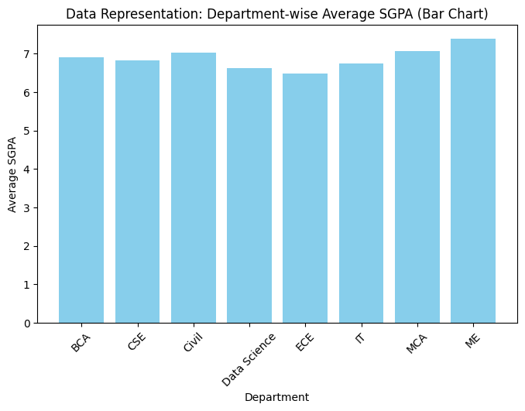
Output:
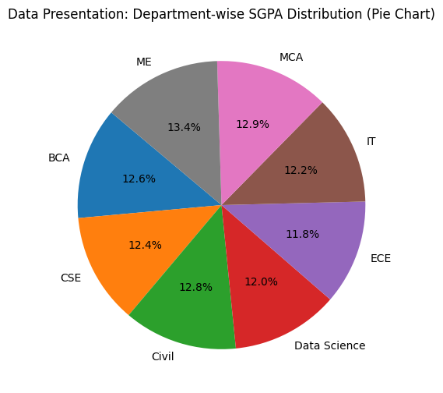

Program No. 04. >> Donut Chart and Purpose of Visualization
Objective: To understand the purpose of data visualization.
Tasks:
- Identify visualization goals for a dataset
- Create a donut chart to represent proportional data
Outcome: Students will understand how visualization supports decision-making.
Tools Used: Python, Matplotlib

Script:
import pandas as pd
import matplotlib.pyplot as plt

# Load the dataset
df = pd.read_csv("MMDU_Student_Performance.csv")

# Count students by specialization
specialization_counts = df["specialization"].value_counts()

# Create a donut chart
plt.figure(figsize=(7, 7))
plt.pie(
specialization_counts,
labels=specialization_counts.index,
autopct="%1.1f%%",
startangle=90,
wedgeprops={"width": 0.4}
)

plt.title("Distribution of Students by Specialization")
plt.show()

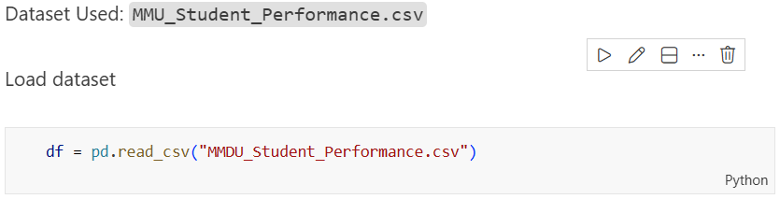
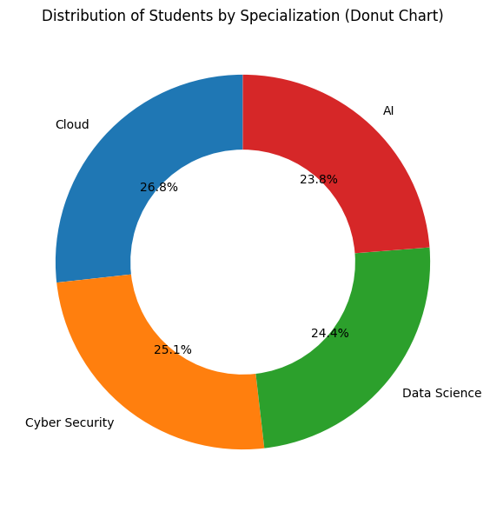
Output:

Program No. 05. >> Seven Stages of Data Visualization
Objective: To study the complete data visualization process.
Tasks:
- Explain the seven stages of data visualization using a simple example
Outcome: Students will understand the end-to-end visualization workflow.
Tools Used: Python, MS Word / Notebook (for explanation)

Script: Uncleaned_Student_Dataset
Attributes include: student_id, roll_number, department, program, academic_year, course_code, attendance_percentage, internal_marks, external_marks, sgpa, gender, age, study_hours
Note: The dataset contains:
- Missing values
- Inconsistent entries (e.g., gender formats, study_hours as text)
- Blank fields: This makes it suitable for explaining the complete visualization workflow.
Seven Stages of Data Visualization
1. Data Collection: Data is collected from raw sources without modification.
Example: Student academic and demographic records collected from different departments and stored as Uncleaned_Student_Dataset.
df = pd.read_csv('Uncleaned_Student_Dataset.csv')
print(df.head())
print(df.info())
2. Data Cleaning: Incorrect, missing, and inconsistent data is identified and handled.
Example:
- Removing or filling missing sgpa values
- Converting gender values like M, Male, female into a standard format
- Replacing text values like five in study_hours with numeric values
# Handle missing values in sgpa
df['sgpa'] = df['sgpa'].fillna(df['sgpa'].mean())
df['course_code'] = df['course_code'].fillna('Unknown')
df['internal_marks'] = df['internal_marks'].fillna(df['internal_marks'].mean())
df['academic_year'] = df['academic_year'].fillna(df['academic_year'].mode())
df['age'] = df['age'].fillna(df['age'].mean())
df['study_hours'] = df['study_hours'].fillna(df['study_hours'].mode())
df['external_marks'] = df['external_marks'].fillna(df['external_marks'].mean())
df['attendance_percentage'] = df['attendance_percentage'].fillna(df['attendance_percentage'].mean())

# Standardize gender values
df['gender'] = df['gender'].str.upper().replace({'FEMALE': 'F', 'MALE': 'M'})

# Convert text study_hours to numeric
study_hours_mapping = {'zero': 0, 'one': 1, 'two': 2, 'three': 3, 'four': 4,
'five': 5, 'six': 6, 'seven': 7}
df['study_hours'] = pd.to_numeric(df['study_hours'], errors='coerce')
df['study_hours'] = df['study_hours'].fillna(df['study_hours'].mean())

print(df.head())
print(df.info())

3. Data Processing: Cleaned data is organized and transformed into usable form.
Example:
- Calculating total marks = internal + external
- Categorizing attendance as low, medium, or high
- Creating age groups
# Calculate total marks
df['total_marks'] = df['internal_marks'] + df['external_marks']

# Categorize attendance as low, medium, or high
df['attendance_category'] = pd.cut(df['attendance_percentage'],
bins=[0, 50, 75, 100],
labels=['Low', 'Medium', 'High'])

# Create age groups
df['age_group'] = pd.cut(df['age'],
bins=[0, 20, 25, 30, 100],
labels=['<20', '20-25', '25-30', '30+'])

print(df[['student_id', 'internal_marks', 'external_marks', 'total_marks',
'attendance_percentage', 'attendance_category', 'age', 'age_group']].head(10))
print(df.info())

4. Data Analysis: Patterns and relationships are explored in the processed data.
Example:
- Analyzing relationship between study_hours and sgpa
- Comparing performance across departments
- Identifying students with low attendance and low marks
# Analyzing relationship between study_hours and sgpa
correlation = df['study_hours'].corr(df['sgpa'])
print(f"Correlation between study_hours and sgpa: {correlation:.4f}")

# Comparing performance across departments
dept_performance = df.groupby('department')[['sgpa', 'total_marks', 'attendance_percentage']].mean()
print("\nDepartment-wise Performance:")
print(dept_performance)

# Identifying students with low attendance and low marks
low_attendance_marks =
df[(df['attendance_percentage'] < 50) & (df['total_marks'] < 50)]
print(f"\nStudents with low attendance (<50%) and low marks (<50): {len(low_attendance_marks)}")
print(low_attendance_marks[['student_id', 'department', 'attendance_percentage',
'total_marks', 'sgpa']])

5. Data Visualization: Graphs and charts are created to represent the analyzed data.
Example:
- Bar chart for department-wise student count
- Pie or donut chart for gender distribution
- Line chart showing academic year trends
# Bar chart for department-wise student count
dept_count = df['department'].value_counts()
plt.figure(figsize=(10, 5))
dept_count.plot(kind='bar', color='skyblue')
plt.title('Department-wise Student Count')
plt.xlabel('Department')
plt.ylabel('Number of Students')
plt.xticks(rotation=45)
plt.tight_layout()
plt.show()

6. Interpretation: The visual outputs are examined to derive meaningful insights.
Example:
- Higher study hours generally lead to better SGPA
- Some departments have consistently higher attendance
- Certain programs need academic support
# Section 6: Interpretation - Key Insights

print("=" * 60)
print("KEY INSIGHTS FROM DATA VISUALIZATION")
print("=" * 60)

# Insight 1: Study Hours vs SGPA Correlation
print(f"\n1. Study Hours vs SGPA Correlation: {correlation:.4f}")
print(" → Weak negative correlation suggests study hours alone don't determine SGPA")
print(" → Other factors like course difficulty and teaching quality matter more")

7. Decision Making: Final decisions are taken based on interpreted insights.
Example:
- Planning remedial classes
- Improving attendance policies
- Allocating faculty based on department strength
Outcome: Students understand the end-to-end data visualization workflow, from an uncleaned dataset to insight-driven decision making.
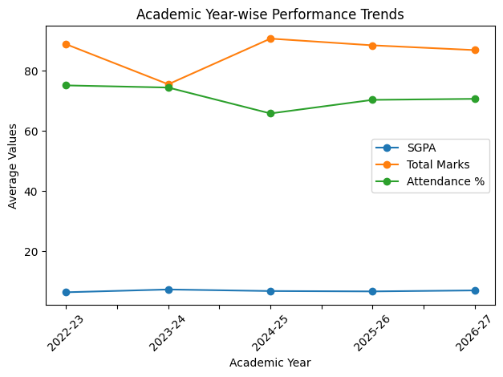
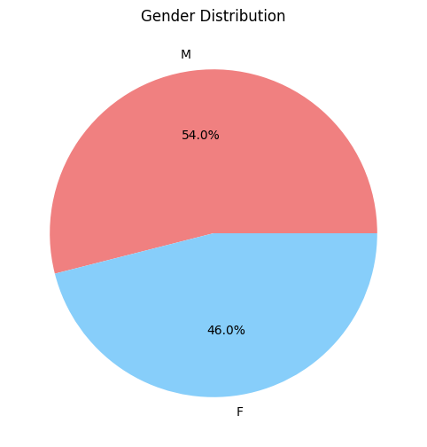
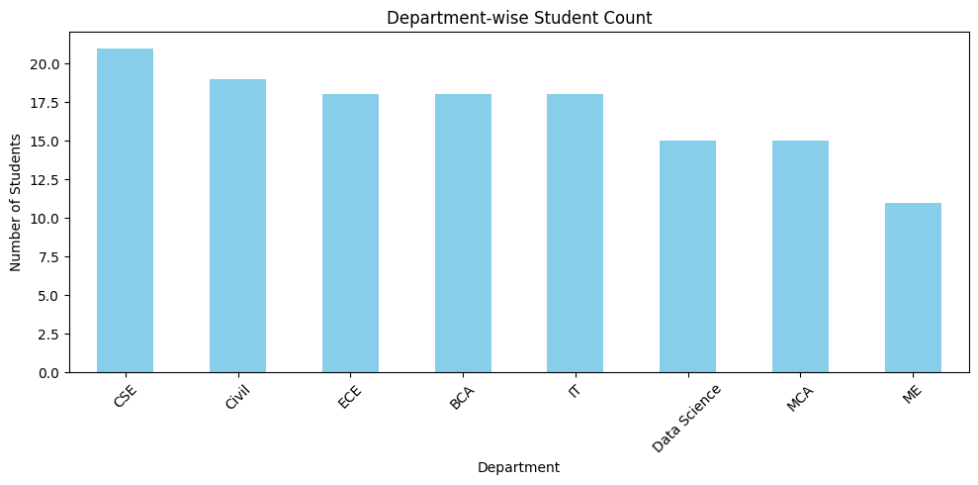
Output:

Program No. 06. >> Basic Visualization Using Any Tool
Objective: To gain hands-on experience with visualization tools.
Tasks:
- Create one basic visualization using Excel / Google Sheets / Tableau / Power BI
Outcome: Students will be able to create basic charts using visualization tools.
Tools Used: Excel / Google Sheets / Tableau / Power BI / Python

Script:
#Bar Chart – Department-wise Average Attendance
- Steps to Create Visualization in Excel
- Open Microsoft Excel
- Import the Uncleaned_Student_Dataset.xlsx
- Make formatting:
  - Fit Column and Width: Alt + H + O + I, Alt + H + O + A
  - Formatting Data: Select row1 ‘Ctrl + B’, Alt + H + B +A
- Select the columns:
  - department
  - attendance percentage
- Use Insert → Pivot Table
  - Rows: Department
  - Values: Average of Attendance Percentage
- Select the Pivot Table
- Go to Insert → Bar Chart
- Add:
  - Chart Title
  - X-axis: Department
  - Y-axis: Average Attendance (%)

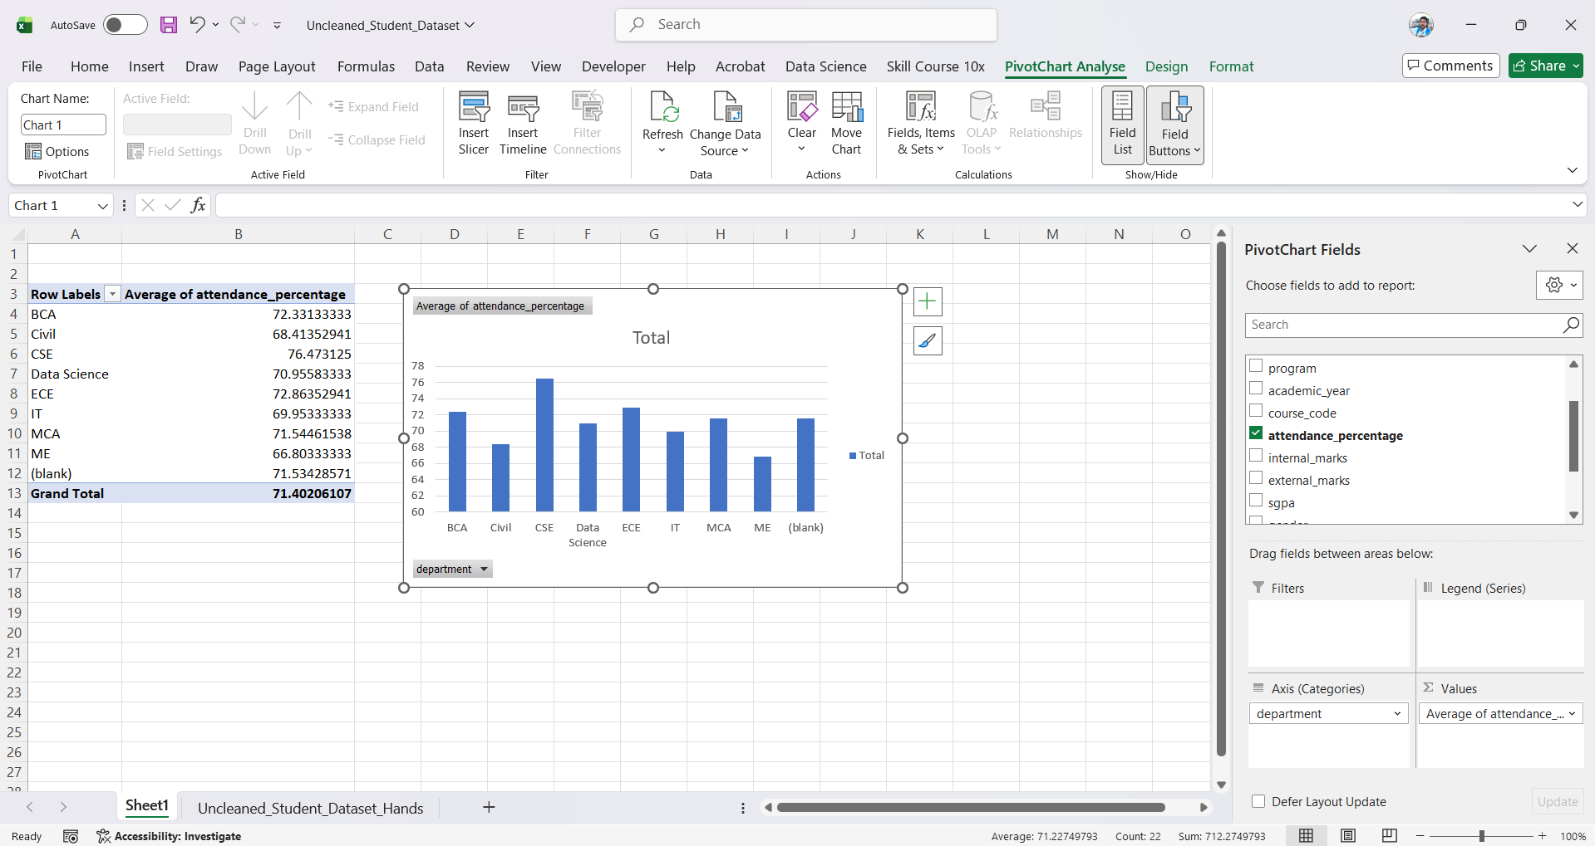
Output:

Program No. 07. >> Area Chart for Time-Series Data
Objective: To visualize cumulative data over time.
Tasks:
- Create an area chart for yearly profit or rainfall data
Outcome: Students will understand growth patterns using area charts.
Tools Used: Python, Matplotlib

Script:
Step 1: Import Libraries
import pandas as pd
import matplotlib.pyplot as plt

Step 2: Load and Prepare Dataset
# Load dataset
df = pd.read_csv("district wise rainfall normal.csv")
# Clean column names
df.columns = df.columns.str.strip()
# Group by State and calculate total annual rainfall
state_rainfall = df.groupby("STATE_UT_NAME")["ANNUAL"].sum().sort_values()
# Convert to DataFrame
state_rainfall = state_rainfall.reset_index()

Step 3: Create Area Chart
plt.figure(figsize=(14, 7))
plt.fill_between(
state_rainfall["STATE_UT_NAME"],
state_rainfall["ANNUAL"],
color="skyblue",
alpha=0.6
)
plt.plot(
state_rainfall["STATE_UT_NAME"],
state_rainfall["ANNUAL"],
color="blue",
linewidth=2
)
plt.xticks(rotation=90)
plt.title("Annual Rainfall Distribution by State (Area Chart)", fontsize=16, fontweight='bold')
plt.xlabel("States / UT")
plt.ylabel("Total Annual Rainfall (mm)")
plt.grid(alpha=0.3)
plt.tight_layout()
plt.show()

Output:
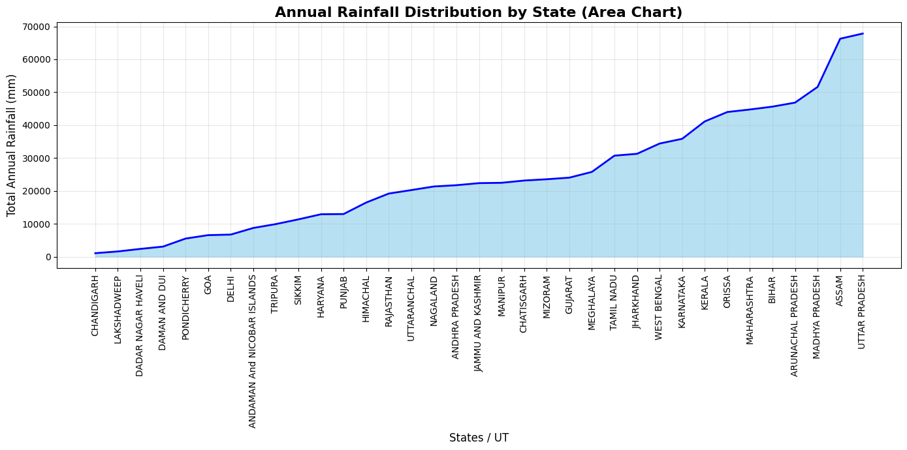

Explanation
• The filled region represents cumulative rainfall values.
• The line overlay improves clarity of trend visualization.
• States with higher rainfall appear more dominant visually.
• Area charts effectively demonstrate comparative growth patterns.

Program No. 08. >> Scatter Plot Analysis
Objective: To study relationships between two variables.
Tasks:
- Draw a scatter plot for study hours vs marks
- Analyse correlation
Outcome: Students will identify relationships between variables.
Tools Used: Python, Matplotlib

Script:
Step 1: Import Libraries
import pandas as pd
import matplotlib.pyplot as plt
import numpy as np

Step 2: Load and Prepare Dataset
# Load dataset
df = pd.read_csv("student_data.csv")
# Clean column names
df.columns = df.columns.str.strip()
# Convert required columns to numeric
df["study_hours_per_day"] = pd.to_numeric(df["study_hours_per_day"], errors="coerce")
df["percentage"] = pd.to_numeric(df["percentage"], errors="coerce")
# Remove missing values
df = df.dropna(subset=["study_hours_per_day", "percentage"])

Step 3: Create Scatter Plot
plt.figure(figsize=(8,6))
plt.scatter(
df["study_hours_per_day"],
df["percentage"],
alpha=0.7
)
plt.title("Scatter Plot: Study Hours vs Percentage", fontweight="bold")
plt.xlabel("Study Hours per Day")
plt.ylabel("Percentage (%)")
plt.grid(alpha=0.3)
plt.tight_layout()
plt.show()

Step 4: Correlation Analysis
correlation = df["study_hours_per_day"].corr(df["percentage"])
print("Correlation Coefficient:", round(correlation, 3))

Enhanced Visualization with Regression Line
plt.figure(figsize=(9,6))
x = df["study_hours_per_day"]
y = df["percentage"]
scatter = plt.scatter(
x, y,
c=y,
cmap="RdYlGn",
edgecolor="black",
alpha=0.8
)
# Regression Line
m, b = np.polyfit(x, y, 1)
plt.plot(x, m*x + b, linestyle="--")
equation = f"Trend: y = {m:.2f}x + {b:.2f}"
plt.legend([equation])
plt.title("Study Hours vs Marks — Scatter Plot", fontsize=14, fontweight="bold")
plt.xlabel("Study Hours per Day")
plt.ylabel("Marks Obtained")
cbar = plt.colorbar(scatter)
cbar.set_label("Marks")
plt.grid(alpha=0.3)
plt.tight_layout()
plt.show()

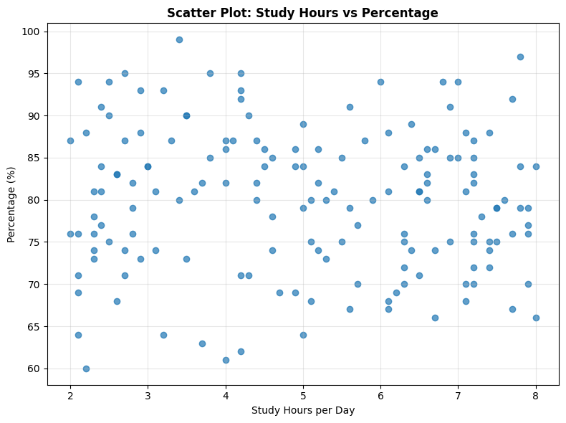
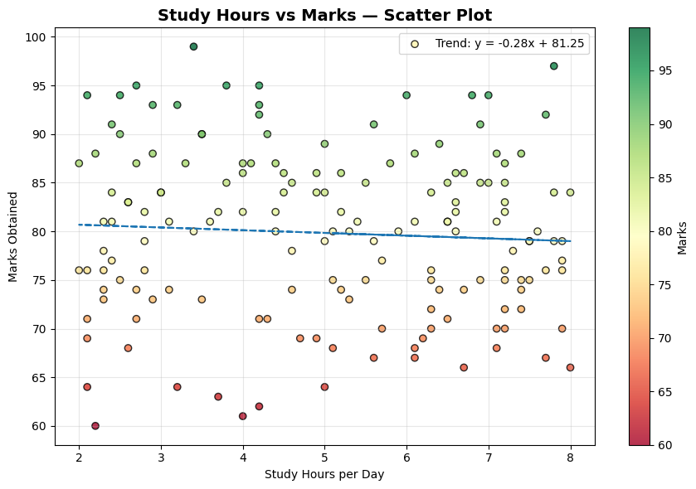
Output:

Program No. 09. >> Pivot Table and Pivot Chart
Objective: To summarize and analyze data.
Tasks:
- Create a pivot table
- Generate a pivot chart from the dataset
Outcome: Students will perform grouped data analysis efficiently.
Tools Used: Python, Pandas, Matplotlib / Excel

Script:
Step 1: Import Libraries
import pandas as pd
import matplotlib.pyplot as plt
import numpy as np

Step 2: Load Dataset
df = pd.read_csv("student_extended.csv")
df.columns = df.columns.str.strip().str.lower()
# Add academic year
years = ["2023", "2024", "2025"]
df["academic_year"] = np.random.choice(years, size=len(df))

Step 3: Create Pivot Table
pivot_table = pd.pivot_table(
df,
index="department",
columns="academic_year",
values="student_id",
aggfunc="count"
)
print(pivot_table)

Step 4: Create Pivot Chart
pivot_table = pivot_table.fillna(0)
departments = pivot_table.index
years = pivot_table.columns
x = np.arange(len(departments))
width = 0.25
plt.figure(figsize=(9,6))
for i, year in enumerate(years):
plt.bar(x + i*width, pivot_table[year], width, label=year)
plt.xlabel("Department")
plt.ylabel("Number of Students")
plt.title("Department-wise Students per Year — Pivot Chart", fontweight="bold")
plt.xticks(x + width, departments)
plt.legend(title="Year")
plt.grid(axis="y", alpha=0.3)
plt.tight_layout()
plt.show()

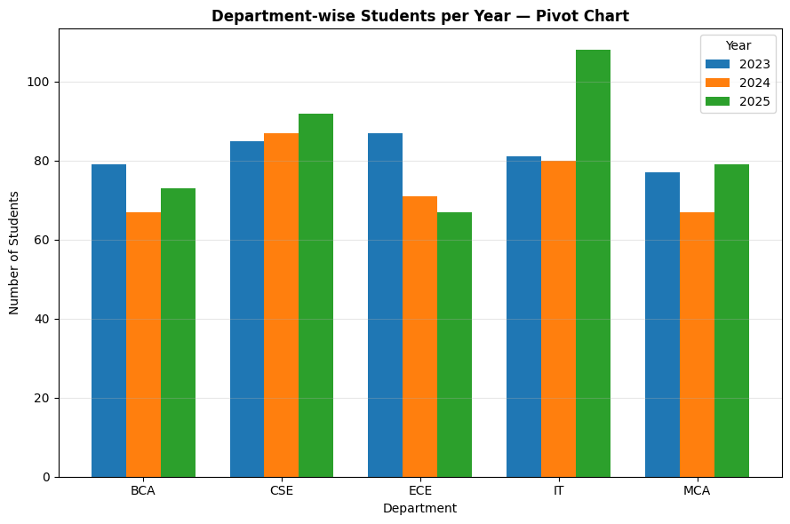
Output:
Explanation:
- Pivot table summarizes student count by department and year.
- Pivot chart visually compares enrolment trends.
- CS department consistently shows highest enrolment.
- Year-wise growth trend is clearly visible.

Program No. 10. >> Tree Map Visualization
Objective: To visualize hierarchical and categorical data.
Tasks:
- Design a tree map for department-wise student count
Outcome: Students will understand hierarchical data visualization.
Tools Used: Python, Squarify, Matplotlib

Script:
Step 1: Install Library
!pip install squarify

Step 2: Import Libraries
import pandas as pd
import matplotlib.pyplot as plt
import squarify

Step 3: Load Dataset
df = pd.read_csv("student_extended.csv")
df.columns = df.columns.str.strip().str.lower()
dept_counts = df["department"].value_counts()

Step 4: Create Tree Map
plt.figure(figsize=(10,6))
labels = [f"{dept}\n{count} students"
for dept, count in zip(dept_counts.index, dept_counts.values)]
sizes = dept_counts.values
colors = plt.cm.Set3(range(len(sizes)))
squarify.plot(
sizes=sizes,
label=labels,
color=colors,
alpha=0.9
)
plt.title("Department-wise Student Count — Tree Map", fontweight="bold")
plt.axis("off")
plt.tight_layout()
plt.show()

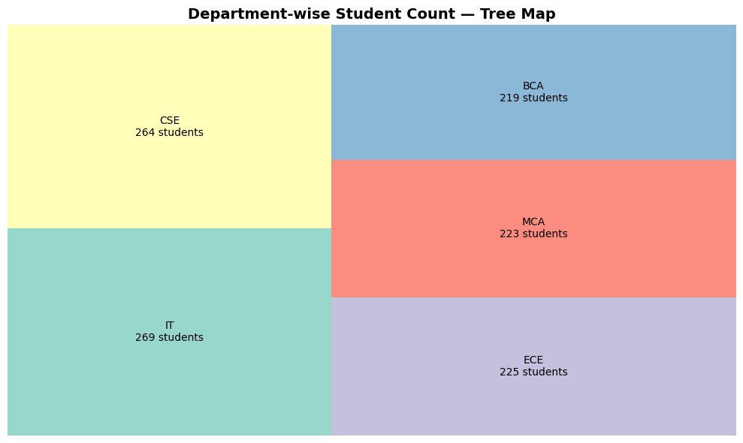
Output:

Explanation:
The Tree Map visualization represents department-wise student distribution using proportional rectangular areas.

Each rectangle corresponds to a department, and its size reflects the total number of students enrolled in that department. Larger rectangles indicate higher student enrolment, while smaller rectangles represent comparatively lower enrolment.

This visualization allows quick comparison of categorical data without using axes, making it efficient for hierarchical and proportional data representation.

Tree maps are especially useful when:
- Comparing categorical distributions
- Visualizing part-to-whole relationships
- Displaying hierarchical institutional data
- Identifying dominant categories instantly

From the analysis, departments with larger rectangles indicate stronger enrollment presence in the institution.

Program No. 11. >> Node-Link Diagram
Objective: To visualize relationships between entities.
Tasks:
- Draw a node-link diagram showing relationships (e.g., friends in a class)
Outcome: Students can build and train basic neural networks.
Tools Used: Python, NetworkX, Matplotlib

Script:
Step 1: Install NetworkX
!pip install networkx

Step 2: Import Libraries
import pandas as pd
import networkx as nx
import matplotlib.pyplot as plt

Step 3: Build Network
df = pd.read_csv("student_extended.csv")
df.columns = df.columns.str.strip().str.lower()
sample_df = df.sample(12, random_state=42)
G = nx.Graph()
for _, row in sample_df.iterrows():
G.add_node(row["roll_number"], department=row["department"])
for i in range(len(sample_df)):
for j in range(i+1, len(sample_df)):
if sample_df.iloc[i]["department"] == sample_df.iloc[j]["department"]:
G.add_edge(sample_df.iloc[i]["roll_number"],
sample_df.iloc[j]["roll_number"])

Step 4: Draw Diagram
plt.figure(figsize=(10,6))
pos = nx.spring_layout(G, seed=42)
nx.draw(
G,
pos,
with_labels=True,
node_size=1200,
node_color="#5DA5DA",
edge_color="gray"
)
plt.title("Student Department Network — Node-Link Diagram", fontweight="bold")
plt.show()

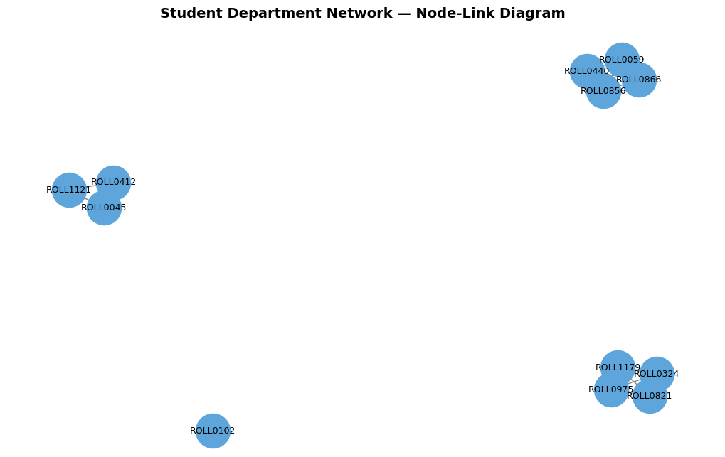
Output:

Explanation:
The Node-Link Diagram represents relationships between students based on department membership.

Each node corresponds to a student, and an edge connects two students if they belong to the same department. This creates clusters within the network graph that represent departmental groupings.

This type of visualization is useful for:
- Social network analysis
- Academic grouping visualization
- Community detection
- Understanding relationship structures

The spring layout algorithm positions nodes based on connection strength, creating a visually intuitive representation of clusters.

Program No. 12. >> Heatmap for Correlation Analysis
Objective: To analyze correlation among numerical variables.
Tasks:
- Create a color-coded correlation matrix (heatmap)
Outcome: Students will analyze relationships among multiple variables.
Tools Used: Python, Pandas, Seaborn, Matplotlib

Script:

Step 1: Import Libraries
import pandas as pd
import matplotlib.pyplot as plt
import seaborn as sns

Step 2: Load Dataset
df = pd.read_csv("student_extended.csv")
df.columns = df.columns.str.strip().str.lower()
numerical_cols = [
"study_hours_per_day",
"attendance_percentage",
"sgpa",
"percentage",
"age"
]
data = df[numerical_cols]

Step 3: Correlation Matrix
corr_matrix = data.corr()
print(corr_matrix)

Step 4: Create Heatmap
plt.figure(figsize=(8,6))
sns.heatmap(
corr_matrix,
annot=True,
cmap="coolwarm",
fmt=".2f",
linewidths=0.5,
square=True
)
plt.title("Correlation Heatmap — Student Performance Analysis",
fontweight="bold")
plt.tight_layout()
plt.show()

Output:
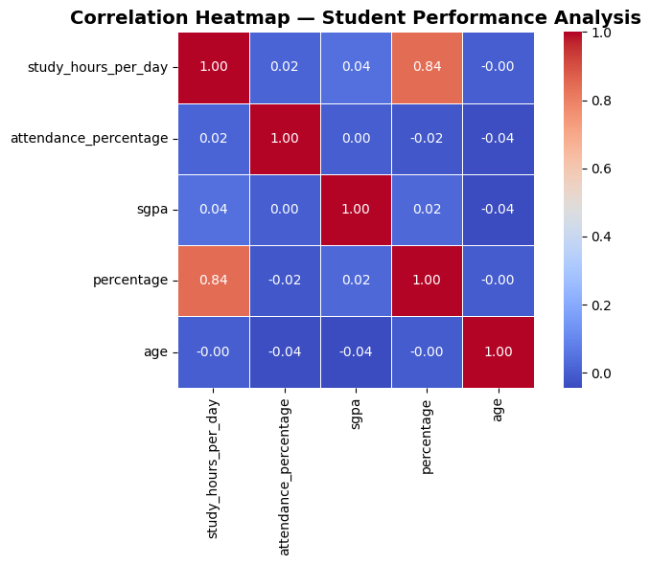

Explanation:
From this heatmap, we typically observe:
- Study hours show positive correlation with percentage.
- Attendance may moderately influence SGPA.
- Percentage and SGPA usually have strong positive correlation.
- Age generally shows weak correlation with academic performance.
- Variables with near zero correlation are largely independent.

This visualization helps in identifying:
- Key performance drivers
- Strongly related academic factors
- Independent variables
- Multicollinearity risks

Practical 13: >> Multi-Variable Time-Series Visualization
Objective: To analyze multiple variables over time.
Tasks:
- Create a time-series visualization with multiple variables
- Analyse observed patterns
Outcome: Students will interpret multi-dimensional time-series data.
Tools Used: Python, Matplotlib

Script:
Step 1: Import Libraries
import pandas as pd
import matplotlib.pyplot as plt
import numpy as np

Step 2: Load and Prepare Dataset
# Load dataset
df = pd.read_csv("student_extended.csv")
df.columns = df.columns.str.strip().str.lower()
# Add academic year (simulate time dimension if not present)
years = ["2023", "2024", "2025"]
df["academic_year"] = np.random.choice(years, size=len(df))
# Convert required columns to numeric & Remove missing values
df["percentage"] = pd.to_numeric(df["percentage"], errors="coerce")
df["sgpa"] = pd.to_numeric(df["sgpa"], errors="coerce")
df["attendance_percentage"] = pd.to_numeric(df["attendance_percentage"], errors="coerce")
df = df.dropna(subset=["percentage", "sgpa", "attendance_percentage"])

Step 3: Aggregate Data Year-wise
yearly_summary = df.groupby("academic_year").agg({
"percentage": "mean",
"sgpa": "mean",
"attendance_percentage": "mean"
}).sort_index()
print(yearly_summary)

Step 4: Create Multi-Variable Time-Series Plot
plt.figure(figsize=(9,6))
plt.plot(yearly_summary.index, yearly_summary["percentage"],
marker="o", linewidth=2, label="Average Percentage")
plt.plot(yearly_summary.index, yearly_summary["sgpa"],
marker="s", linewidth=2, label="Average SGPA")
plt.plot(yearly_summary.index, yearly_summary["attendance_percentage"],
marker="^", linewidth=2, label="Average Attendance")
plt.title("Multi-Variable Time-Series Analysis (2023–2025)",
fontsize=14, fontweight="bold")
plt.xlabel("Academic Year")
plt.ylabel("Average Value")
plt.legend()
plt.grid(alpha=0.3)
plt.tight_layout()
plt.show()

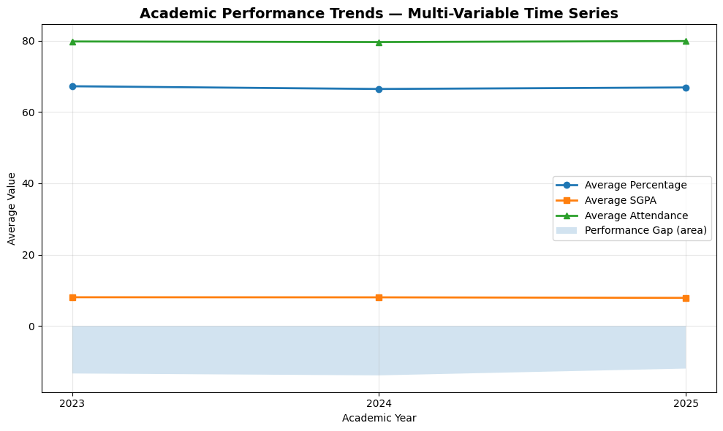
Output:

Explanation:
From the time-series visualization:
- Trends in academic performance can be observed across years.
- If percentage and SGPA rise together, it indicates consistent academic improvement.
- Attendance trends may influence overall performance.
- Parallel movement of lines suggests positive correlation.
- Diverging trends indicate independent performance factors.
This multi-variable time-series analysis helps in:
- Monitoring institutional academic trends
- Identifying improvement or decline periods
- Comparing performance indicators simultaneously
- Supporting data-driven academic decisions.
Program No. 14. >> Text Data Visualization
Objective: To visualize textual data.
Tasks:
- Count word frequency from a paragraph
- Plot text visualization
Outcome: Students will understand basic text visualization techniques.
Tools Used: Python, WordCloud, Matplotlib

Script:
Step 1: Install Library
pip install wordcloud

Step 2: Import Libraries
import pandas as pd
import matplotlib.pyplot as plt
from wordcloud import WordCloud
from collections import Counter
import re

Step 3: Load Dataset
df = pd.read_csv("student_extended.csv")
df.columns = df.columns.str.strip().str.lower()

Step 4: Combine Text Columns
text_data = (
df["specialization"].astype(str) + " " +
df["program"].astype(str) + " " +
df["learning_style"].astype(str)
)
text_corpus = " ".join(text_data)

Step 5: Clean Text
text_corpus = text_corpus.lower()
text_corpus = re.sub(r'[^a-z\s]', '', text_corpus)
words = text_corpus.split()
words = [word for word in words if len(word) > 2]

Step 6: Word Frequency
word_freq = Counter(words)
top_words = word_freq.most_common(10)
print(top_words)

Step 7: Bar Chart
words_list, counts = zip(*top_words)
plt.bar(words_list, counts)
plt.title("Top Frequent Words")
plt.xticks(rotation=45)
plt.show()

Step 8: WordCloud
wordcloud = WordCloud(width=800, height=400).generate(text_corpus)
plt.imshow(wordcloud)
plt.axis("off")
plt.show()

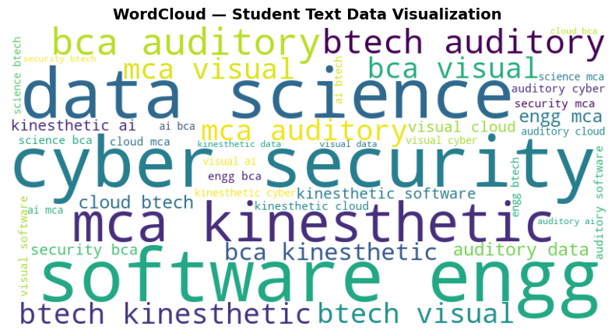
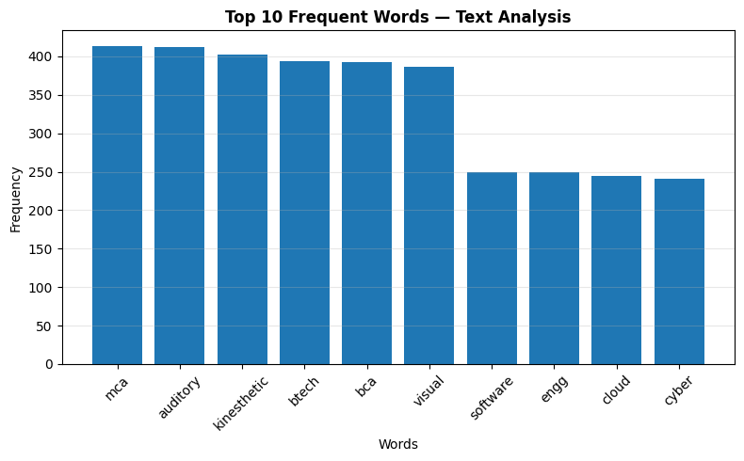
Output:

Program No. 15. >> Multivariate Chart Visualization
Objective: To visualize more than two variables simultaneously.
Tasks:
- Create a multivariate chart using marks in three subjects
Outcome: Students will analyze complex datasets visually.
Tools Used: Python, Matplotlib

Script:
Step 1: Import Libraries
import pandas as pd
import matplotlib.pyplot as plt

Step 2: Load Dataset
df = pd.read_csv("student_extended.csv")
df.columns = df.columns.str.strip().str.lower()

Step 3: Convert Numeric Columns
df["percentage"] = pd.to_numeric(df["percentage"], errors="coerce")
df["sgpa"] = pd.to_numeric(df["sgpa"], errors="coerce")
df["attendance_percentage"] = pd.to_numeric(df["attendance_percentage"], errors="coerce")
df["study_hours_per_day"] = pd.to_numeric(df["study_hours_per_day"], errors="coerce")
df = df.dropna()

Step 4: Bubble Chart
plt.scatter(
df["study_hours_per_day"],
df["percentage"],
s=df["sgpa"]*40,
c=df["attendance_percentage"],
cmap="viridis"
)
plt.xlabel("Study Hours")
plt.ylabel("Percentage")
plt.colorbar(label="Attendance %")
plt.show()

Output:

From the visualization:
- Students studying more hours generally achieve higher percentages.
- Larger bubbles indicate higher SGPA.
- Darker color indicates better attendance.
- High-performing students tend to cluster in the upper-right region.
- Students with low attendance often show lower academic performance.

This multivariate chart helps in:
- Identifying performance patterns
- Detecting outliers
- Understanding interaction between variables
- Analyzing academic behavior visually
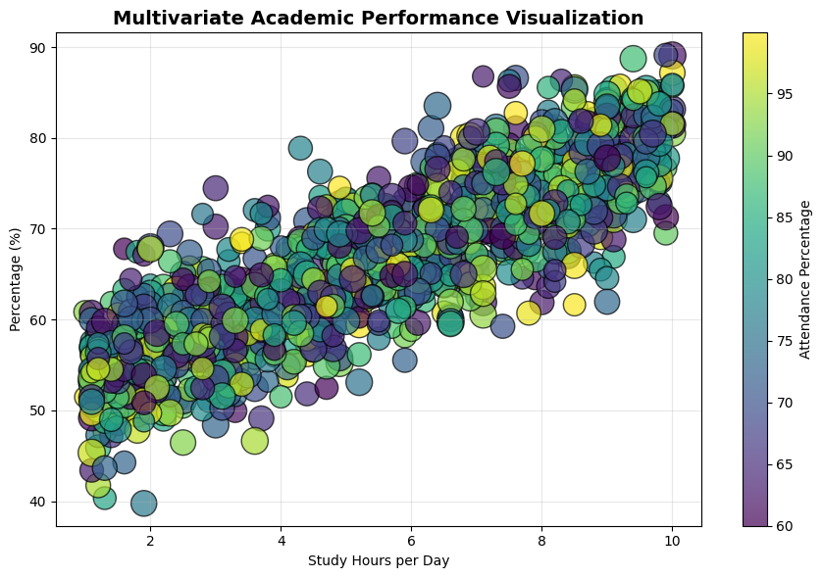
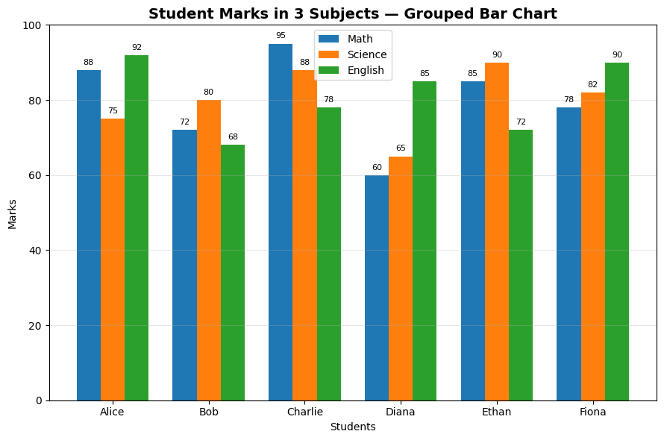

Program No. 16. >> Case Study on Visualization
Objective: To study real-life applications of visualization.
Tasks:
- Analyze a small case where visualization improves understanding
Outcome: Students will appreciate visualization in real-world decision-making.
Tools Used: Python, Jupyter Notebook / MS Word.

Script:
Step 1: Import Libraries
import pandas as pd
import matplotlib.pyplot as plt
import numpy as np
import seaborn as sns
sns.set_theme(style="whitegrid")

Step 2: Load Dataset
df = pd.read_csv("district wise rainfall normal.csv")
df.columns = df.columns.str.strip().str.upper()
state_rainfall = df.groupby("STATE_UT_NAME")["ANNUAL"].mean().reset_index()
# Select Top 8 States
state_rainfall = state_rainfall.sort_values("ANNUAL", ascending=False).head(8)

Step 3: Aggregate State-wise Rainfall
state_rainfall = df.groupby("STATE_UT_NAME").agg({
"ANNUAL": "mean",
"JAN": "mean",
"FEB": "mean",
"MAR": "mean"
}).reset_index()
# Select top 5 states for clear visualization
state_rainfall = state_rainfall.sort_values("ANNUAL", ascending=False).head(5)
print(state_rainfall)

Step 4: Visualization 1 — Rainfall Distribution
plt.figure(figsize=(8,5))
plt.barh(state_rainfall["STATE_UT_NAME"],
state_rainfall["ANNUAL"])
national_avg = state_rainfall["ANNUAL"].mean()
plt.axvline(national_avg, linestyle="--", label="Average Rainfall")
plt.xlabel("Average Annual Rainfall (mm)")
plt.title("Rainfall Distribution by State — Case Study",
fontweight="bold")
plt.legend()
plt.grid(axis="x", alpha=0.3)
plt.tight_layout()
plt.show()
plt.figure(figsize=(9,6))
sns.barplot(
data=state_rainfall,
x="ANNUAL",
y="STATE_UT_NAME",
palette="viridis"
)
plt.axvline(state_rainfall["ANNUAL"].mean(),
linestyle="--",
color="red",
label="Average Rainfall")
plt.title("State-wise Annual Rainfall Analysis",
fontsize=14,
fontweight="bold")
plt.xlabel("Average Annual Rainfall (mm)")
plt.ylabel("State / UT")
plt.legend()
plt.tight_layout()
plt.show()

Visualization 2 — Seasonal vs Annual Rainfall
plt.figure(figsize=(8,5))
bubble_size = state_rainfall["JAN"] * 5
scatter = plt.scatter(
state_rainfall["FEB"],
state_rainfall["ANNUAL"],
s=bubble_size,
alpha=0.6
)
for i, txt in enumerate(state_rainfall["STATE_UT_NAME"]):
plt.annotate(txt,
(state_rainfall["FEB"].iloc[i],
state_rainfall["ANNUAL"].iloc[i]))
plt.xlabel("Average February Rainfall")
plt.ylabel("Annual Rainfall")
plt.title("Seasonal vs Annual Rainfall (Bubble = January Rain)",
fontweight="bold")
plt.grid(alpha=0.3)
plt.tight_layout()
plt.show()
dept_avg = df.groupby("department")["percentage"].mean().sort_values()
plt.figure(figsize=(9,5))
dept_avg.plot(kind="bar")
plt.title("Department-wise Average Percentage",
fontweight="bold")
plt.xlabel("Department")
plt.ylabel("Average Percentage")
plt.grid(axis="y", alpha=0.3)
plt.tight_layout()
plt.show()

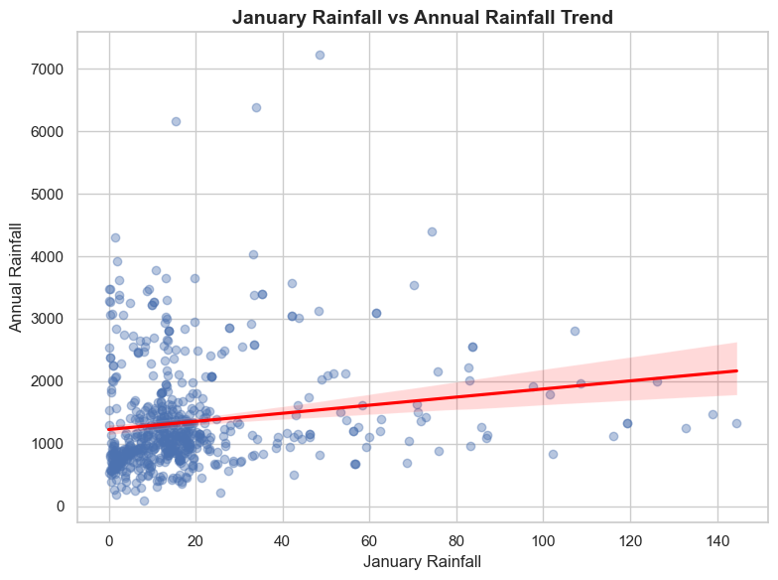
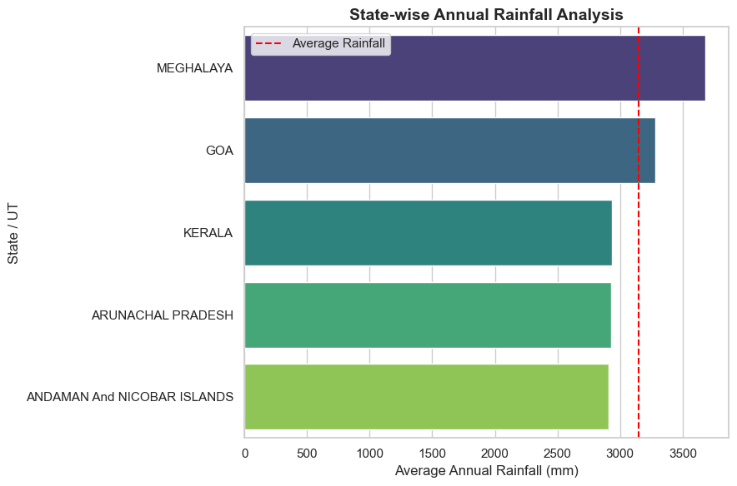
Output:

Conclusion (Case Study Analysis):
- States above the national average line receive higher rainfall.
- Water resource allocation can prioritize low-rainfall states.
- Larger bubbles indicate high January rainfall contribution.
- Seasonal dependency patterns can be identified.
- Visualization helps policymakers take data-driven decisions.

Program No. 17. >> Live-like Data Visualization
Objective: To simulate real-time data visualization.
Tasks:
- Create a live-like visualization using continuously updated values
Outcome: Students will understand real-time monitoring concepts.
Tools Used: Python, Matplotlib, Time module.

Script:
Step 1: Import Libraries
import matplotlib.pyplot as plt
import random
import time

Step 2: Live Updating Graph
plt.ion() # Turn on interactive mode
x_values = []
y_values = []
plt.figure(figsize=(8,5))
for i in range(20): # Simulate 20 live updates
new_score = random.randint(60, 95)
x_values.append(i)
y_values.append(new_score)
plt.clf()
plt.plot(x_values, y_values, marker='o')
plt.title("Live Academic Performance Monitoring",
fontsize=14,
fontweight="bold")
plt.xlabel("Time (Seconds)")
plt.ylabel("Average Class Score")
plt.ylim(50, 100)
plt.grid(alpha=0.3)
plt.pause(1)
plt.ioff()
plt.show()

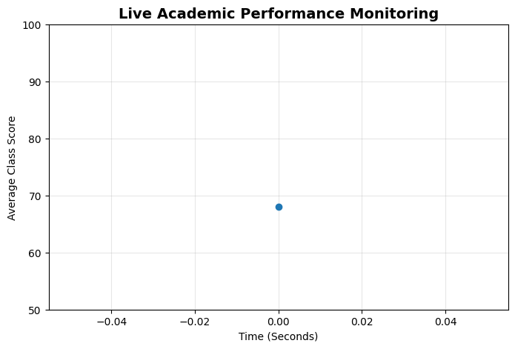
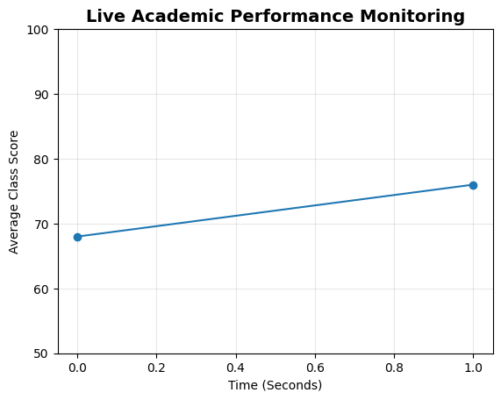
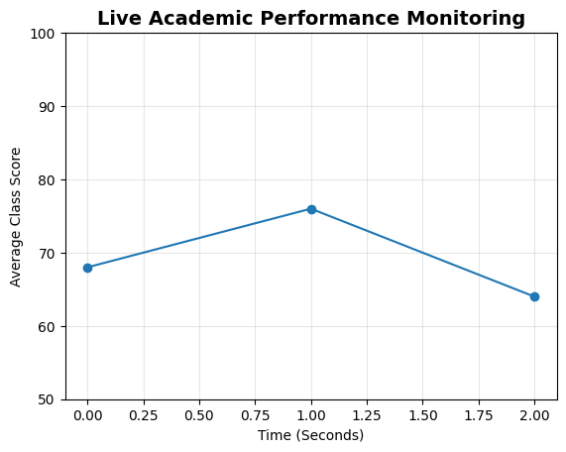
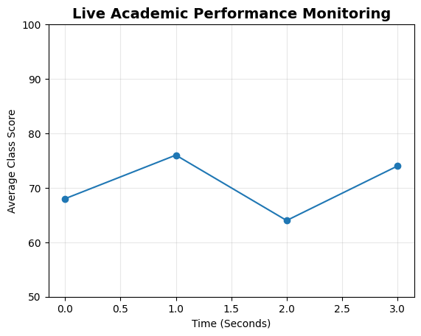
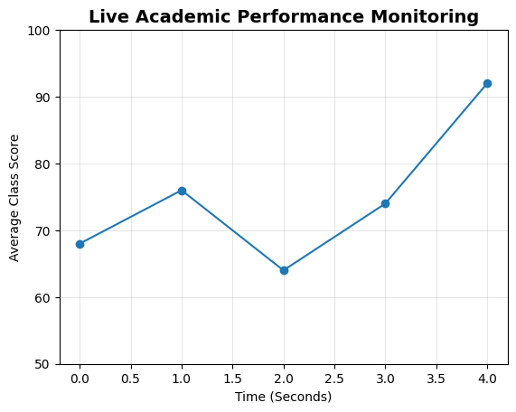
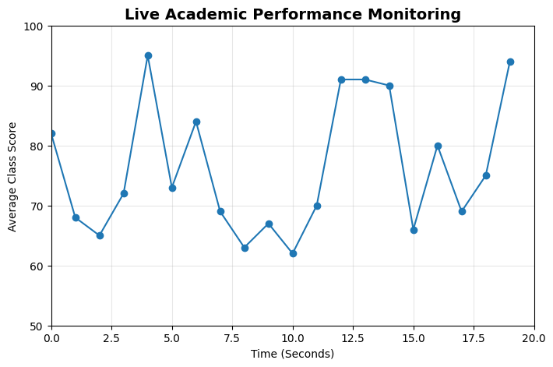
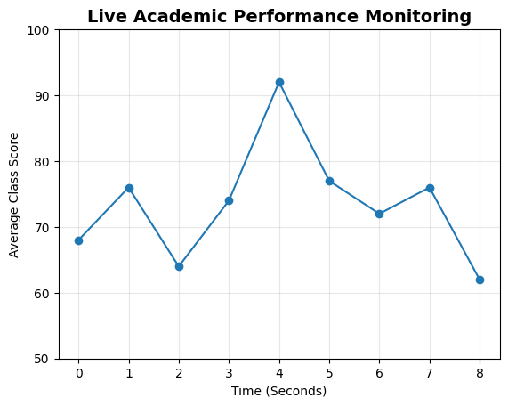
Output:

Applications of Live Visualization:
- Stock market dashboards
- Hospital patient monitoring
- Weather tracking systems
- Traffic monitoring
- Network performance tracking
- Academic attendance monitoring

Explanation:
- Trend changes are visible immediately
- Sudden drops indicate issues
- Continuous growth shows improvement
- Enables instant decision making

Program No. 18. >> Visualization Best Practices
Objective: To learn principles of effective visualization.
Tasks:
- Write rules or best practices for good visualizations with examples
Outcome: Students will design meaningful and clear visualizations.
Tools Used: MS Word / Notebook, Python (examples).

Script:

Output:

Program No. 19. >> Open and Closed Port Visualization
Objective: To visualize basic network security data.
Tasks:
- Create a chart showing open and closed ports
Outcome: Students will understand visualization of network status.
Tools Used: Python, Matplotlib.

Script:

Output:

Program No. 20. >> Firewall Log Visualization
Objective: To identify suspicious traffic using visualization.
Tasks:
- Visualize firewall log data
- Identify suspicious traffic patterns
Outcome: Students will detect anomalies using visual analysis.
Tools Used: Python, Pandas, Matplotlib.

Script:

Output:

Program No. 21. >> Intrusion Detection Visualization
Objective: To analyze intrusion detection logs.
Tasks:
- Design intrusion detection log visualization
- Highlight possible attacks
Outcome: Students will understand visualization in cybersecurity.
Tools Used: Python, Pandas, Matplotlib.

Script:

Output:

Program No. 22. >> Sentiment Analysis Visualization
Objective: To analyze sentiment from social media data.
Tasks:
- Implement sentiment analysis on live tweet data using Python libraries
Outcome: Students will apply NLP techniques for visualization.
Tools Used: Python, TextBlob / NLTK, Matplotlib.

Script:

Output:

Program No. 23. >> Secure Data Visualization Architecture
Objective: To design a secure visualization system.
Tasks:
- Design secured data visualization architecture
- Explain security measures used
Outcome: Students will understand security considerations in visualization systems.
Tools Used: Scikit-learn, Pandas, NumPy.

Script:

Output:

Program No. 24. >> Tree Map Visualization
Objective: To visualize hierarchical and categorical data.
Tasks:
- Design a tree map for department-wise student count
Outcome: Students will understand hierarchical data visualization.
Tools Used: Python (conceptual), Diagram Tool (Draw.io / MS PowerPoint).

Script:

Output:

